SIT120 - Introduction to Responsive Web Apps Week 1: Introduction to HTML, CSS

**List of Tasks:  
Pass Task 1 – Create an HTML Page**

Learning reflections:

HTML is a markup language which is used to create web pages. It stands for HyperText Markup Language. There are different html elements which have different attribute properties to describe and structure the web page contents.

Below is the screenshot of simple web page & html code.

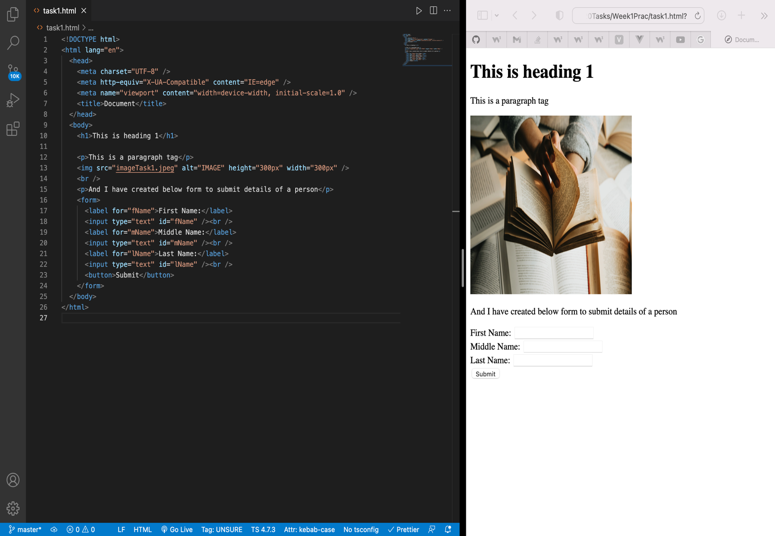

**Pass Task 2 – Add CSS to your HTML page**

CSS stands for Cascading Style Sheets which is used to decorate webpages. There three different ways to add css properties in html elements.

1. Inline
2. Internal
3. External

Below is a web page after implementation of CSS styling.

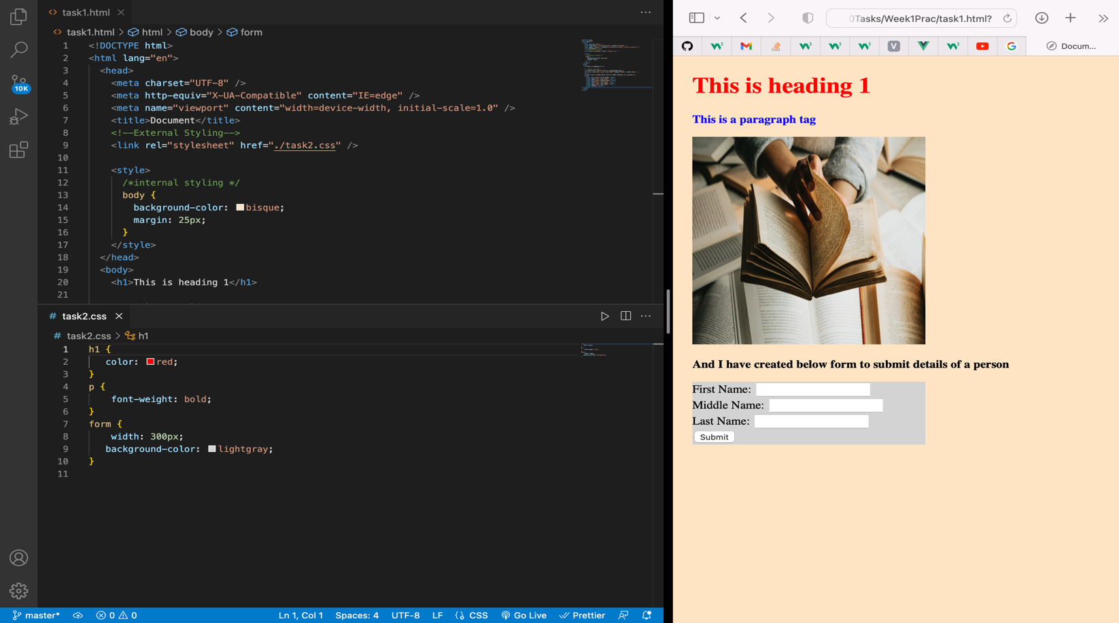

**Pass Task 3 – Adding JavaScript**

JavaScript is a scripting language that adds functionality to the html elements and makes the webpage responsive with the users.

Below webpage shows that if a user clicks the button “Current Date & Time” it displays current date & time

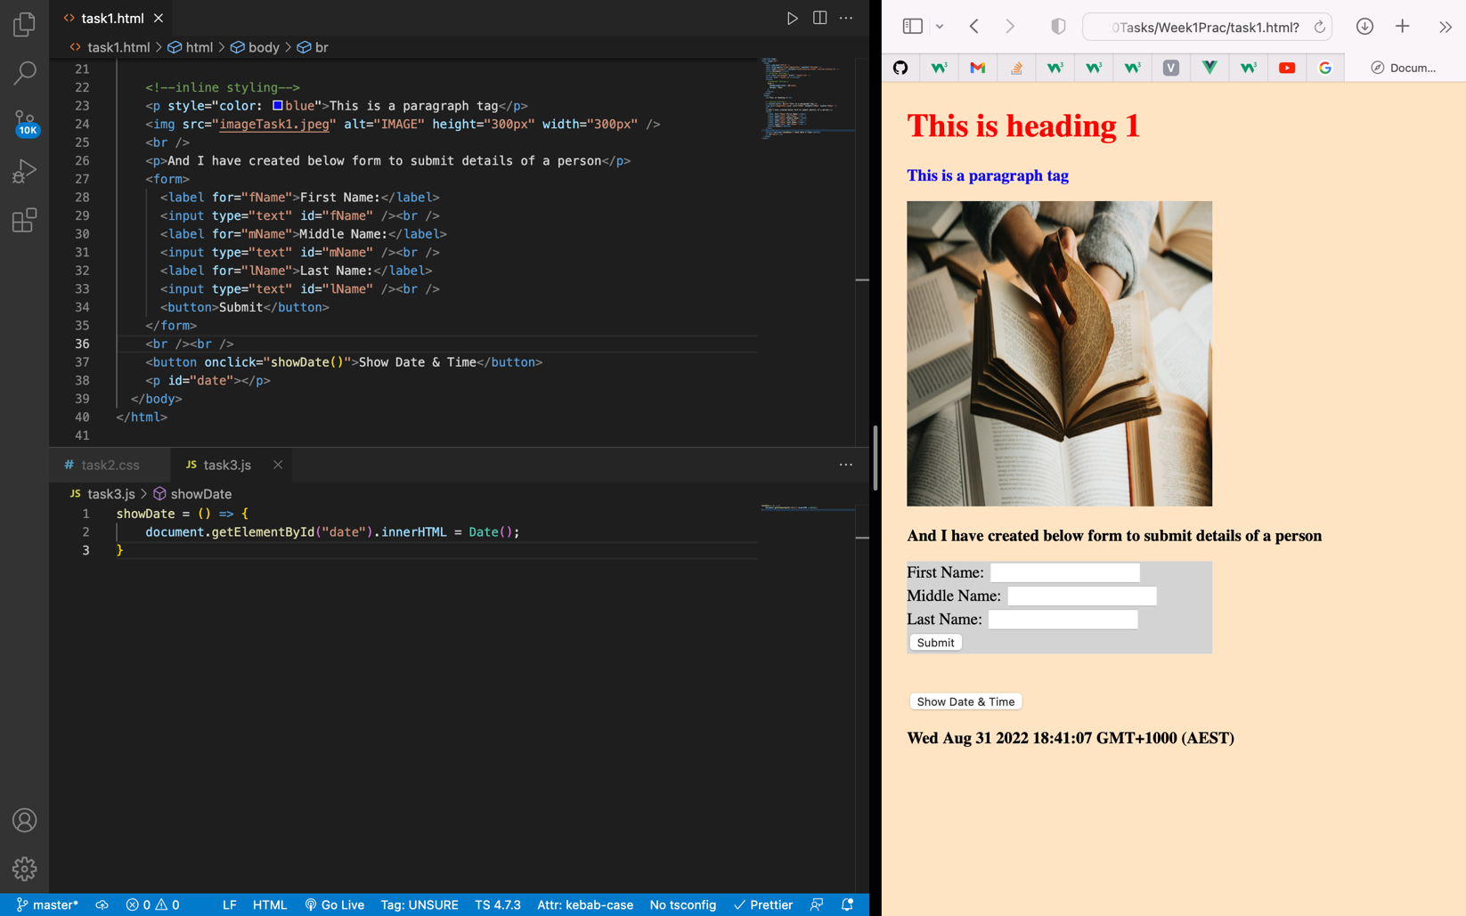

**Pass Task 4 – How to use Git and GitHub**

To use GitHub, we must create an account. Once the account is created, we can create a repository where we can add our project files and share it with other users to collaborate in the project.

Below is the screenshot of the page after a repository is created.

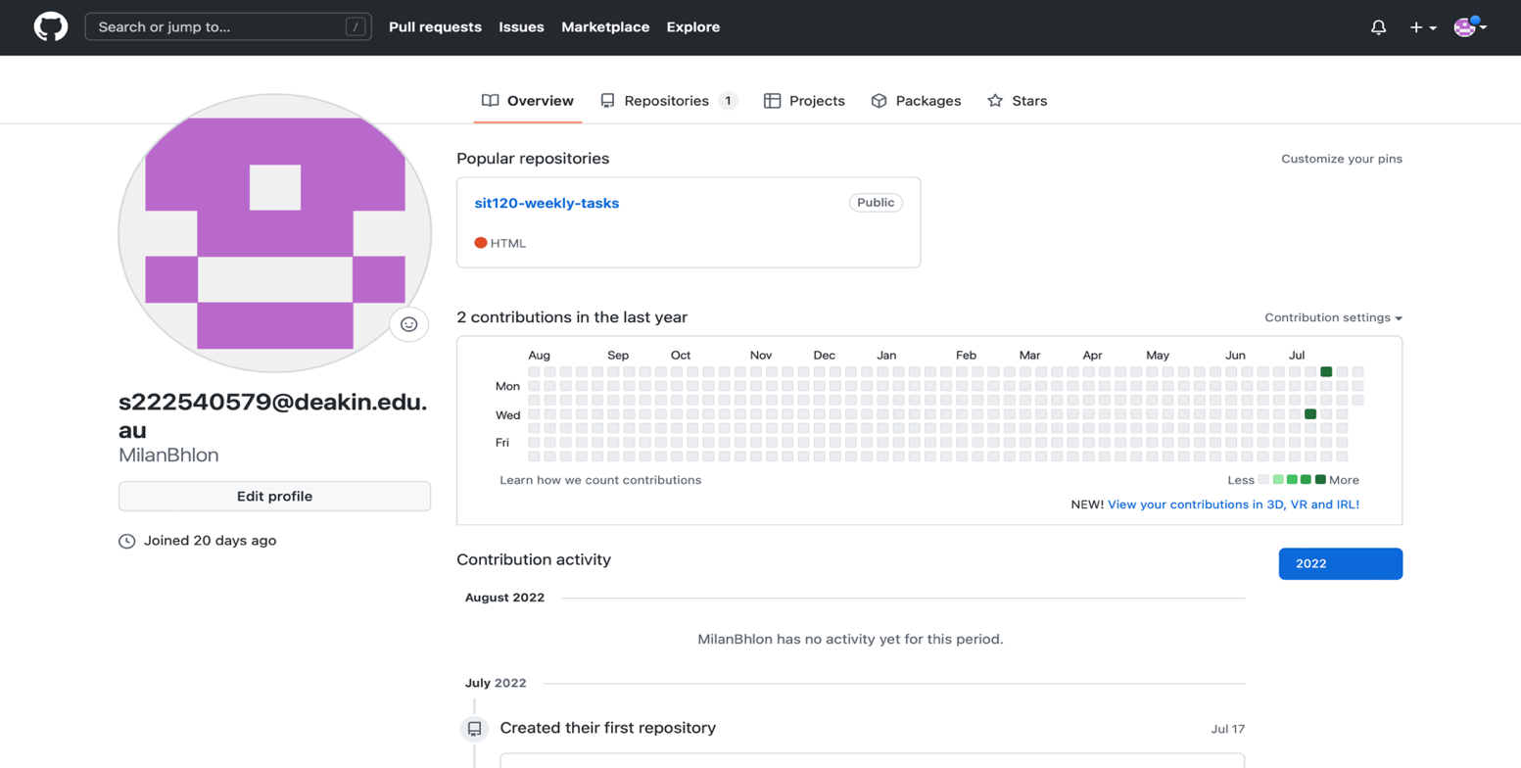

**Credit Task 5 – Vue.js Framework (homework)**

Vue is a JavaScript framework for building user interfaces. It builds on top of standard HTML, CSS and JavaScript, and provides a declarative and component-based programming model that helps you efficiently develop user interfaces, be it simple or complex.

Below is a simple vue todo app.

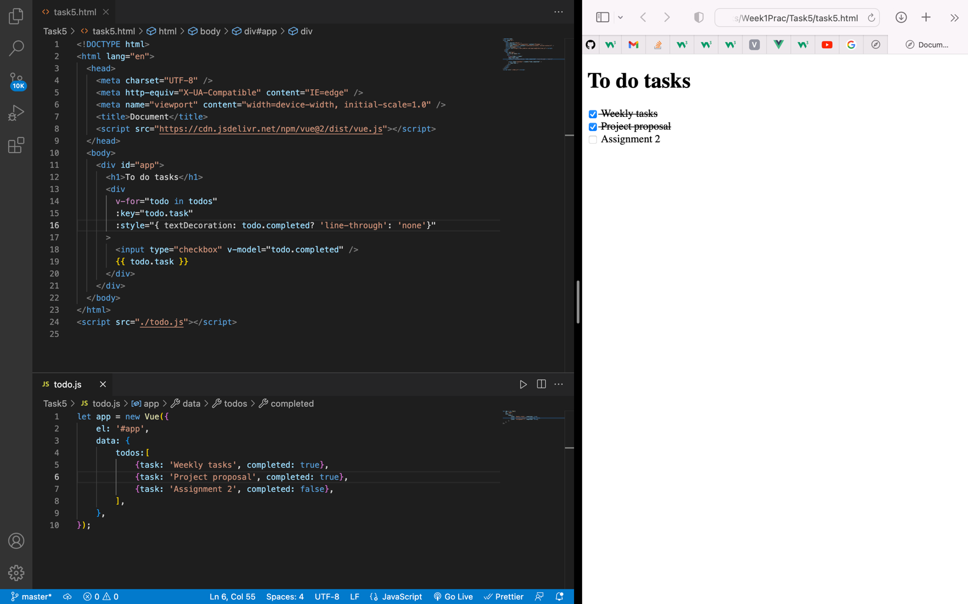

SIT120 – WEEK 2

**Overview:**

Learning Reflections:

This week we learned the concept of responsive web design which helps to design a website to display the contents in mobile devices without compromising its quality. This can be achieved by considering different factors such as screen size, device type etc.

**List of Tasks:  
Pass Task 1 – Understand about responsive web Pages and apps**

* Responsive web design is a way of designing web pages in such a way where it responds to user needs depending on the devices they’re using. Responsive web pages change the layout based on the size & capabilities of the device. For example, on an iPhone, users would see content shown in a single column view; a tablet might show the same content in two columns.

Responsive web design is important because it helps us to design sites which can adapt to different mobile devices which are often constrained by display size & additional features today or in future for users’ better experience.

As you can see in the below images that the site is responsive to different devices as per their display size.

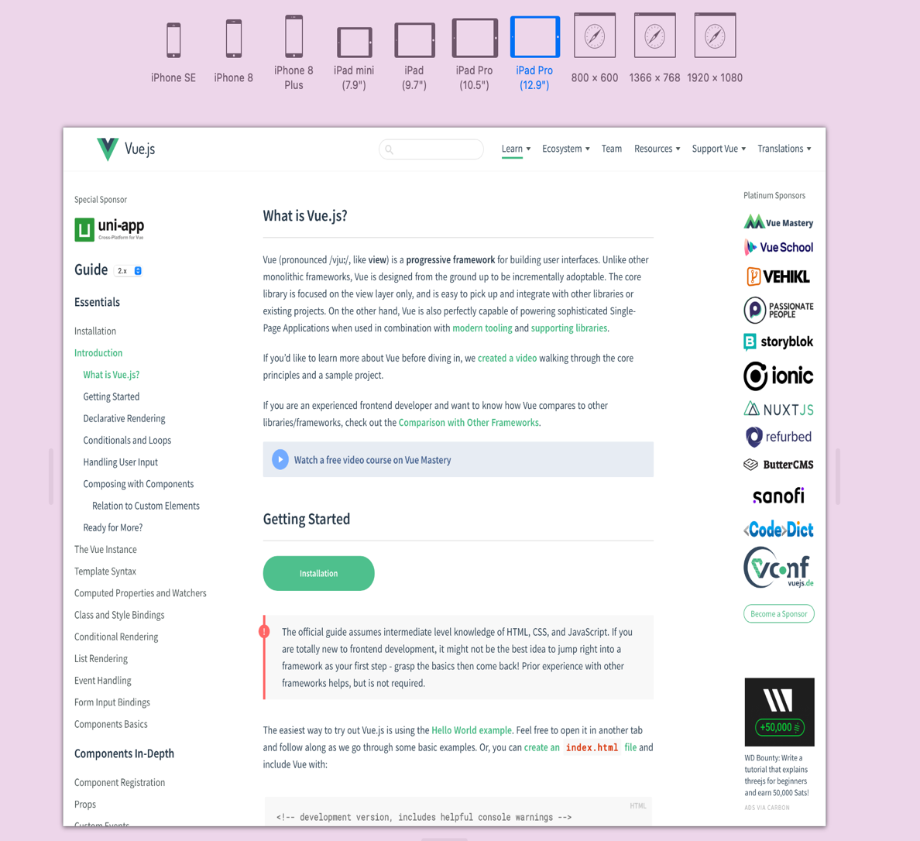

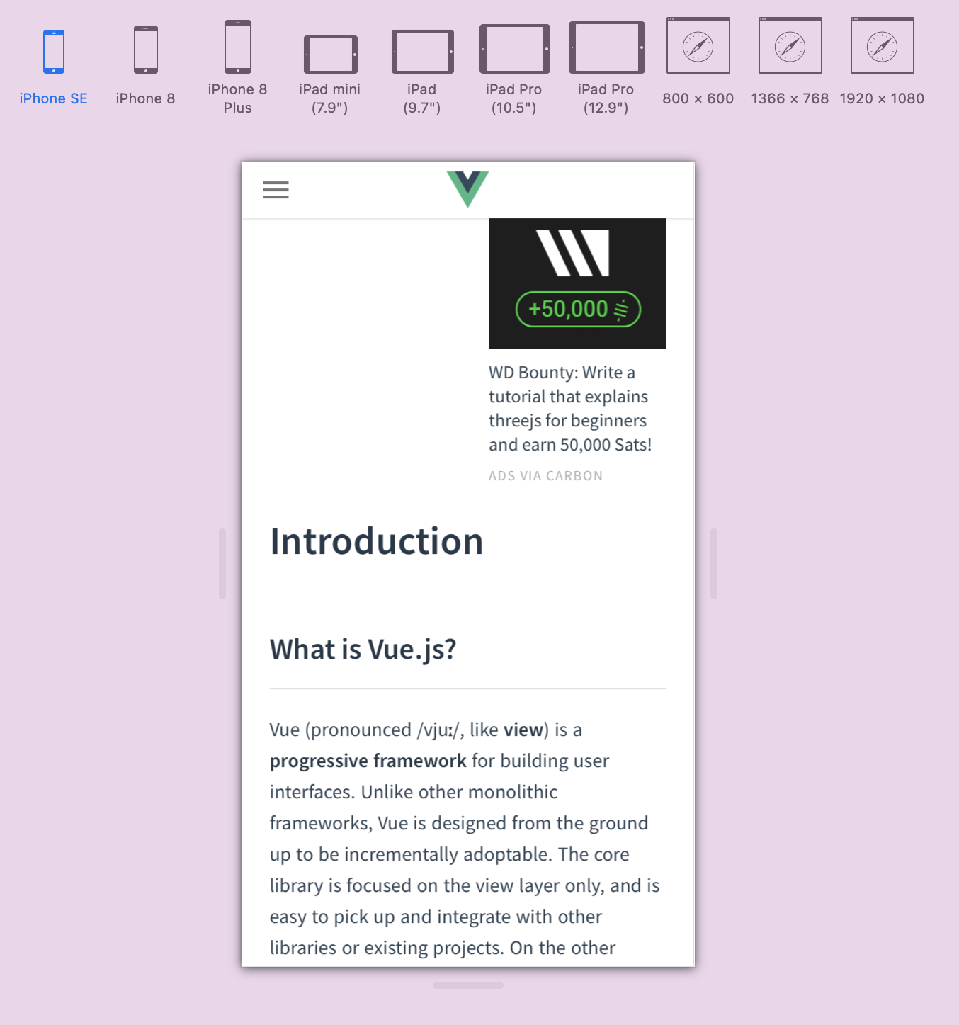

**Pass Task 2 – Understanding how responsive web design can be implemented using CSS Instruction:**

**CSS media queries for responsive web design implementation**

Sometimes more extensive changes are needed to support layout in different screen sizes. Media queries become useful in this kind of scenario.

Media queries are simple filters that can be applied to CSS styles which make it easy to change styles based on the types of devices rendering the content, or the features of that device. For example, width, height, orientation, ability to hover, and whether the device is being used as a touchscreen.

**Screenshots**

Below screenshots shows how @medai rule can be implemented. It shows that when the device screen maximum width is <=600px, the background colour changes to light-blue and when the device screen width is >600px, the background colour changes to yellow.

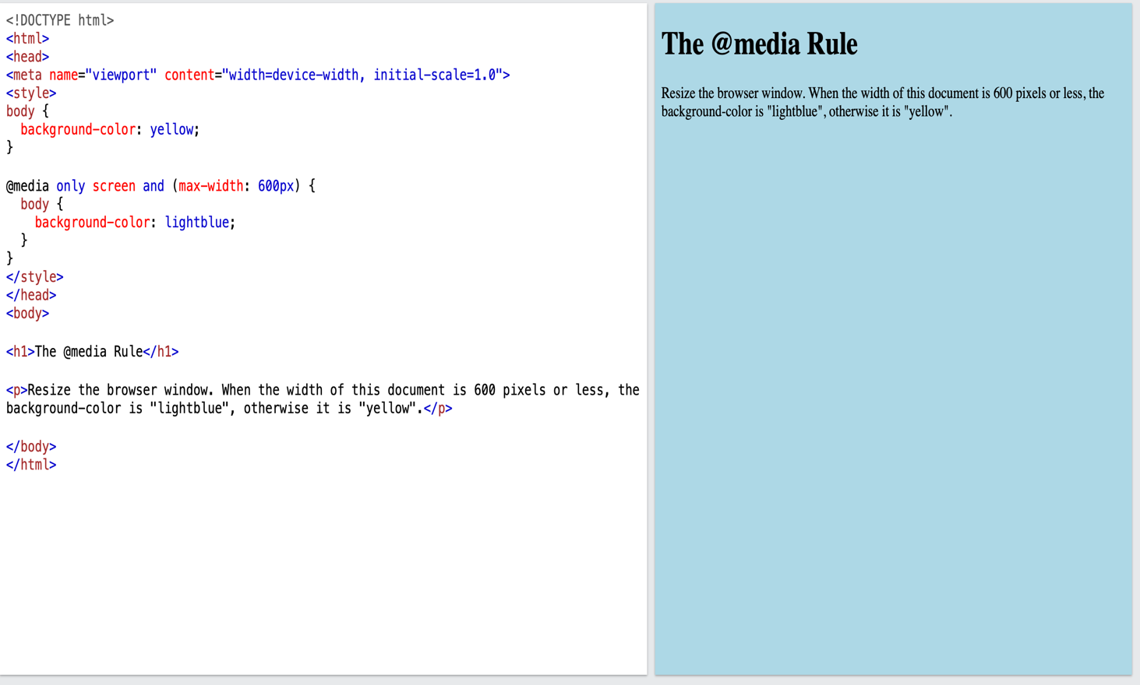

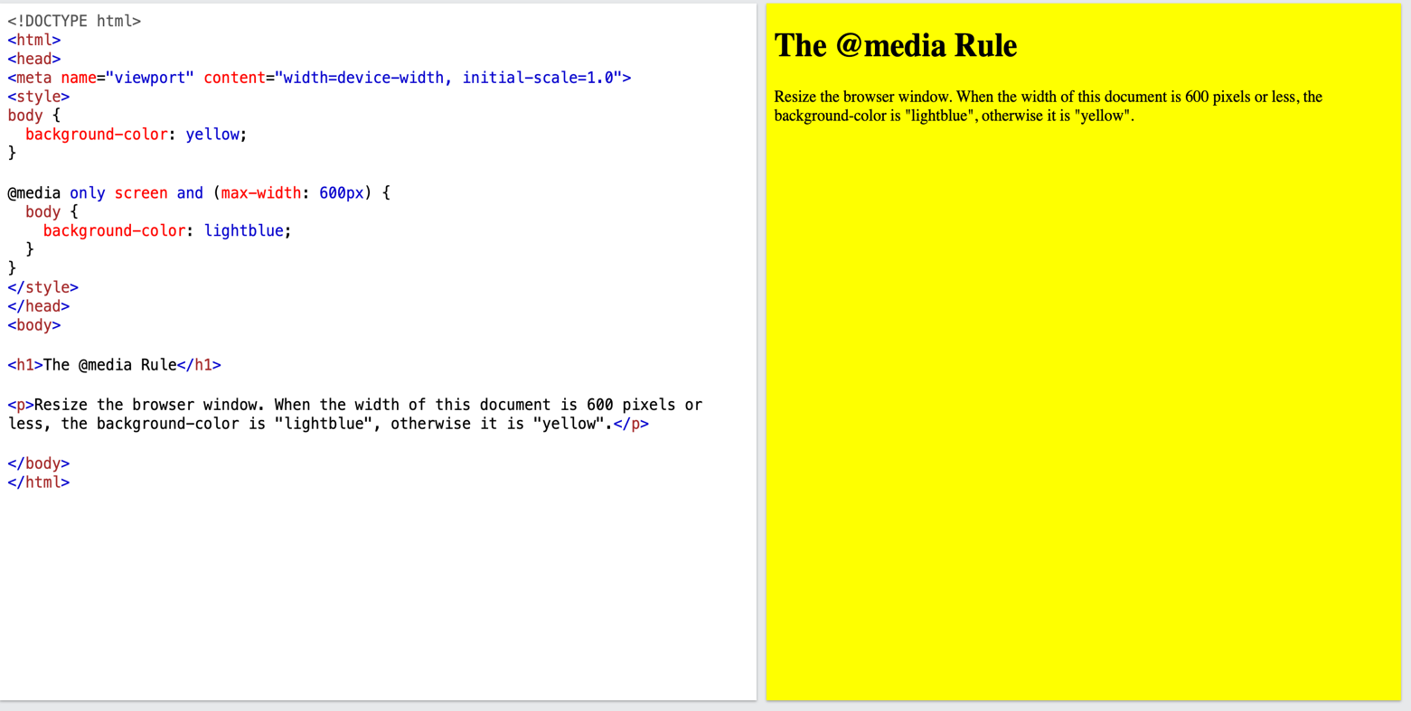

**Credit Task 3 – User stories and UI/UX design for your project**

* User stories are important because it helps to clarify the software functionality which make the development process easier. Similarly, UI/UX protype helps to demonstrate user stories in an effective graphical manner and helps to figure out any challenges before starting the UI tasks.

**User Stories:**

1. **As a member, I want to create either a public or private profile**
   1. Members should be able to enter their personal details
   2. Verify the details & complete the signup process
   3. Once the member is logged into their profile, there should be an option to make the profile public or private
   4. Member should be able to update more details about their health & fitness once they are logged in to maintain proper track record of their fitness journey
   5. There should be an option to upload profile picture
   6. There should be an option to upload recent & past pictures of the member is fitness gallery to create a visual track record
2. **As a member, I want to update my profile**
   1. Member should be able to update their profile in profile setting page
   2. Should be able to change profile picture
   3. Should be able to add or delete pictures from the fitness gallery
   4. Should be able to change their profile type either from private to public mode or vice-versa
   5. They should be able to update their new or change old details

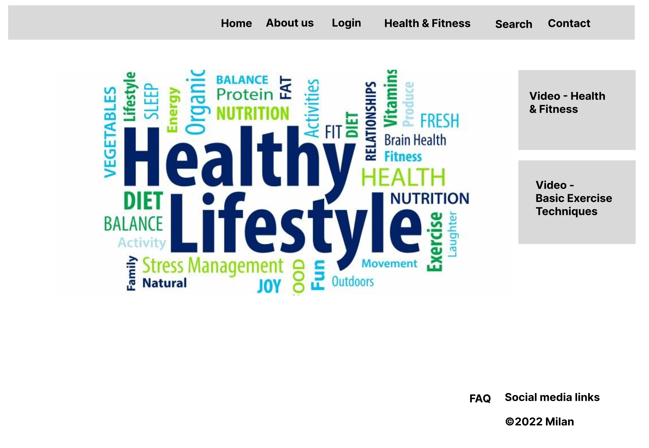Below 3 images are the UX/UI design for my project

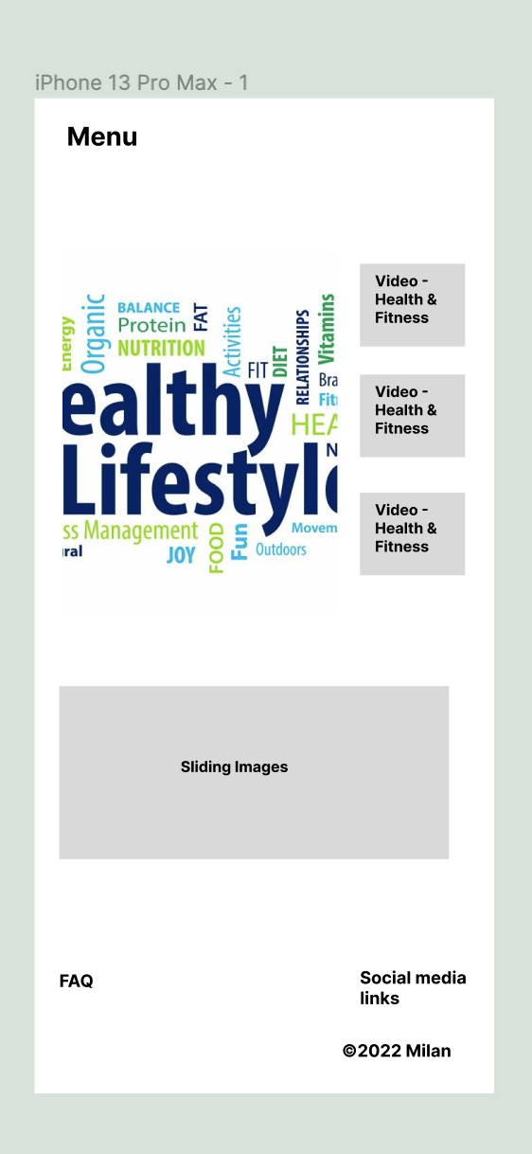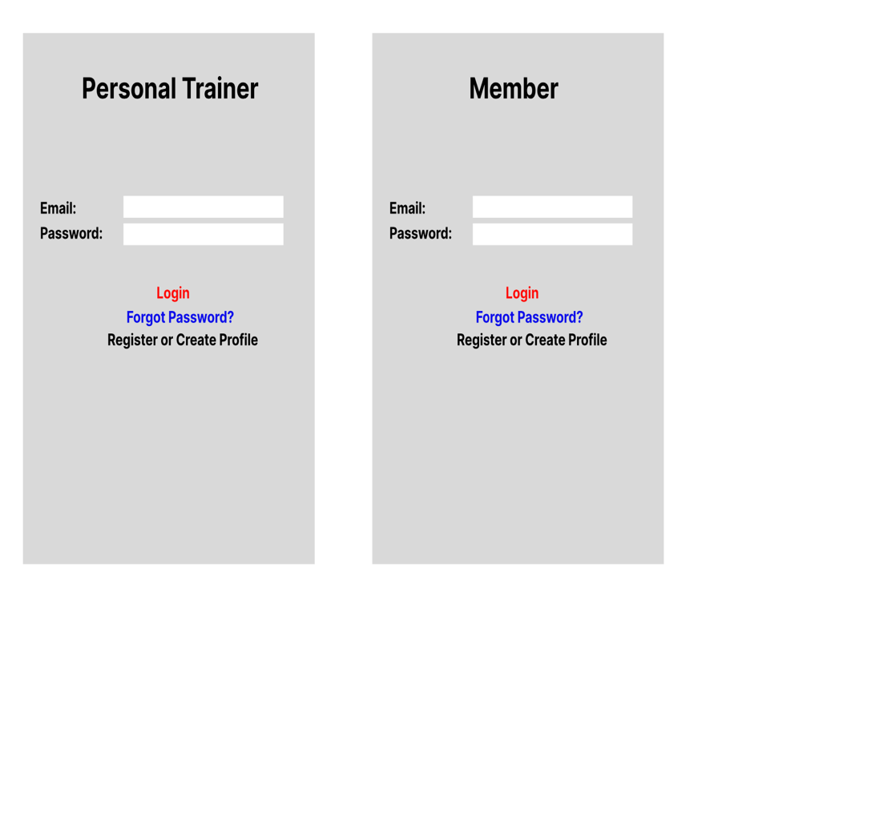

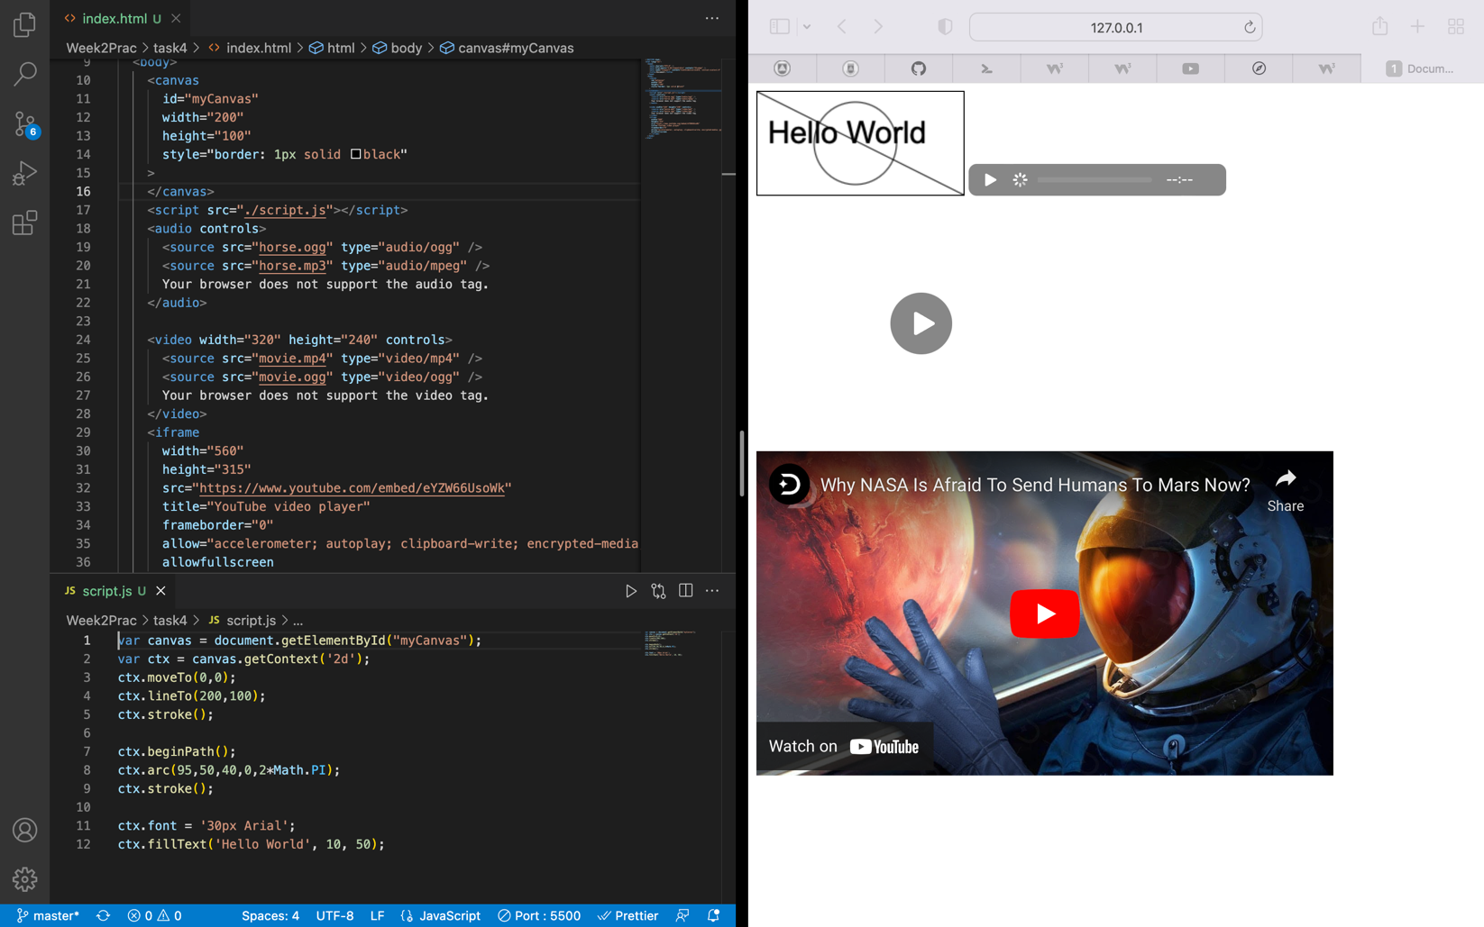**Distinction Task 4 – Use graphics, media and APIs (Homework)**

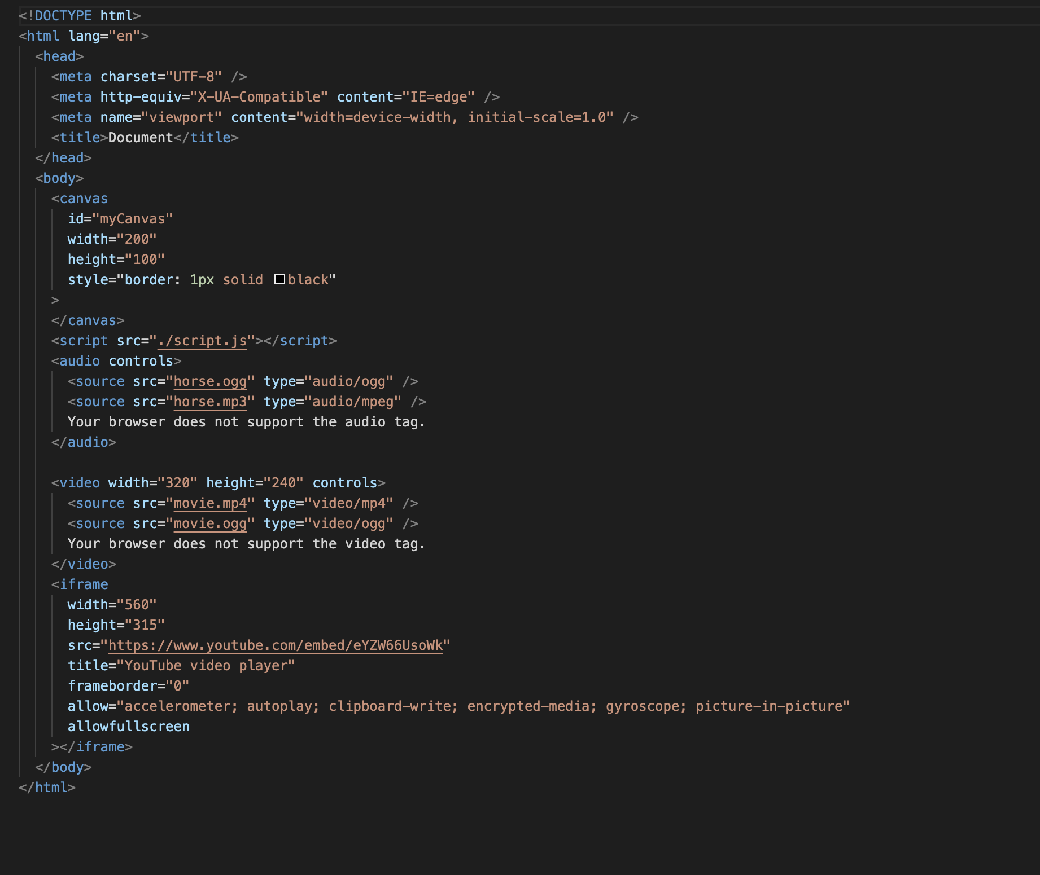

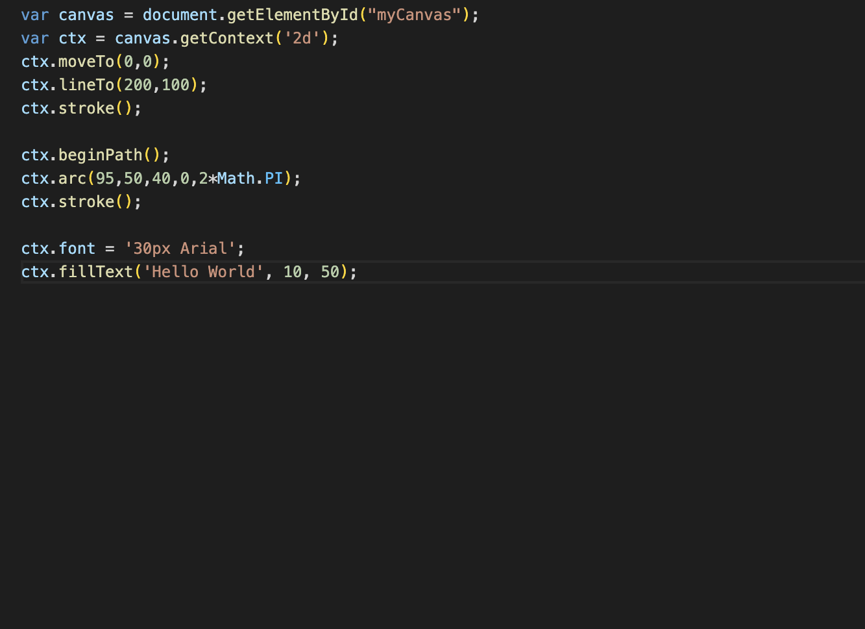

SIT120 - Introduction to Responsive Web Apps Week 3: JavaScript Functions

**Overview:**

In this week, your goal is to gain better understanding of the web using basic JavaScript applications. Learn definitions of some new concepts/components. Note 1-2 sentences reflections for each task.

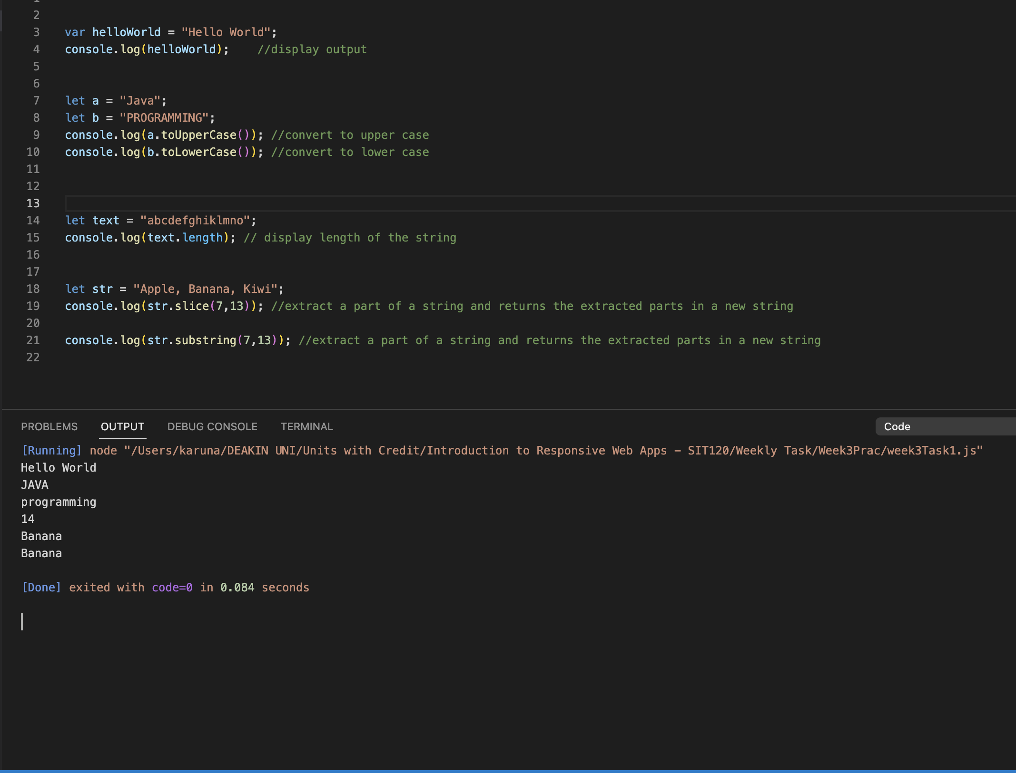**List of Tasks:  
Pass Task 1 – JavaScript String Methods**

Reflection:

This task helped me to learn about different string methods and implement them to work with strings.

**Pass Task 2 – JavaScript Number, Number Methods and Array Methods**

Reflection: This task helps me to understand about different number and array methods and implement them to manipulate the string and number arrays.

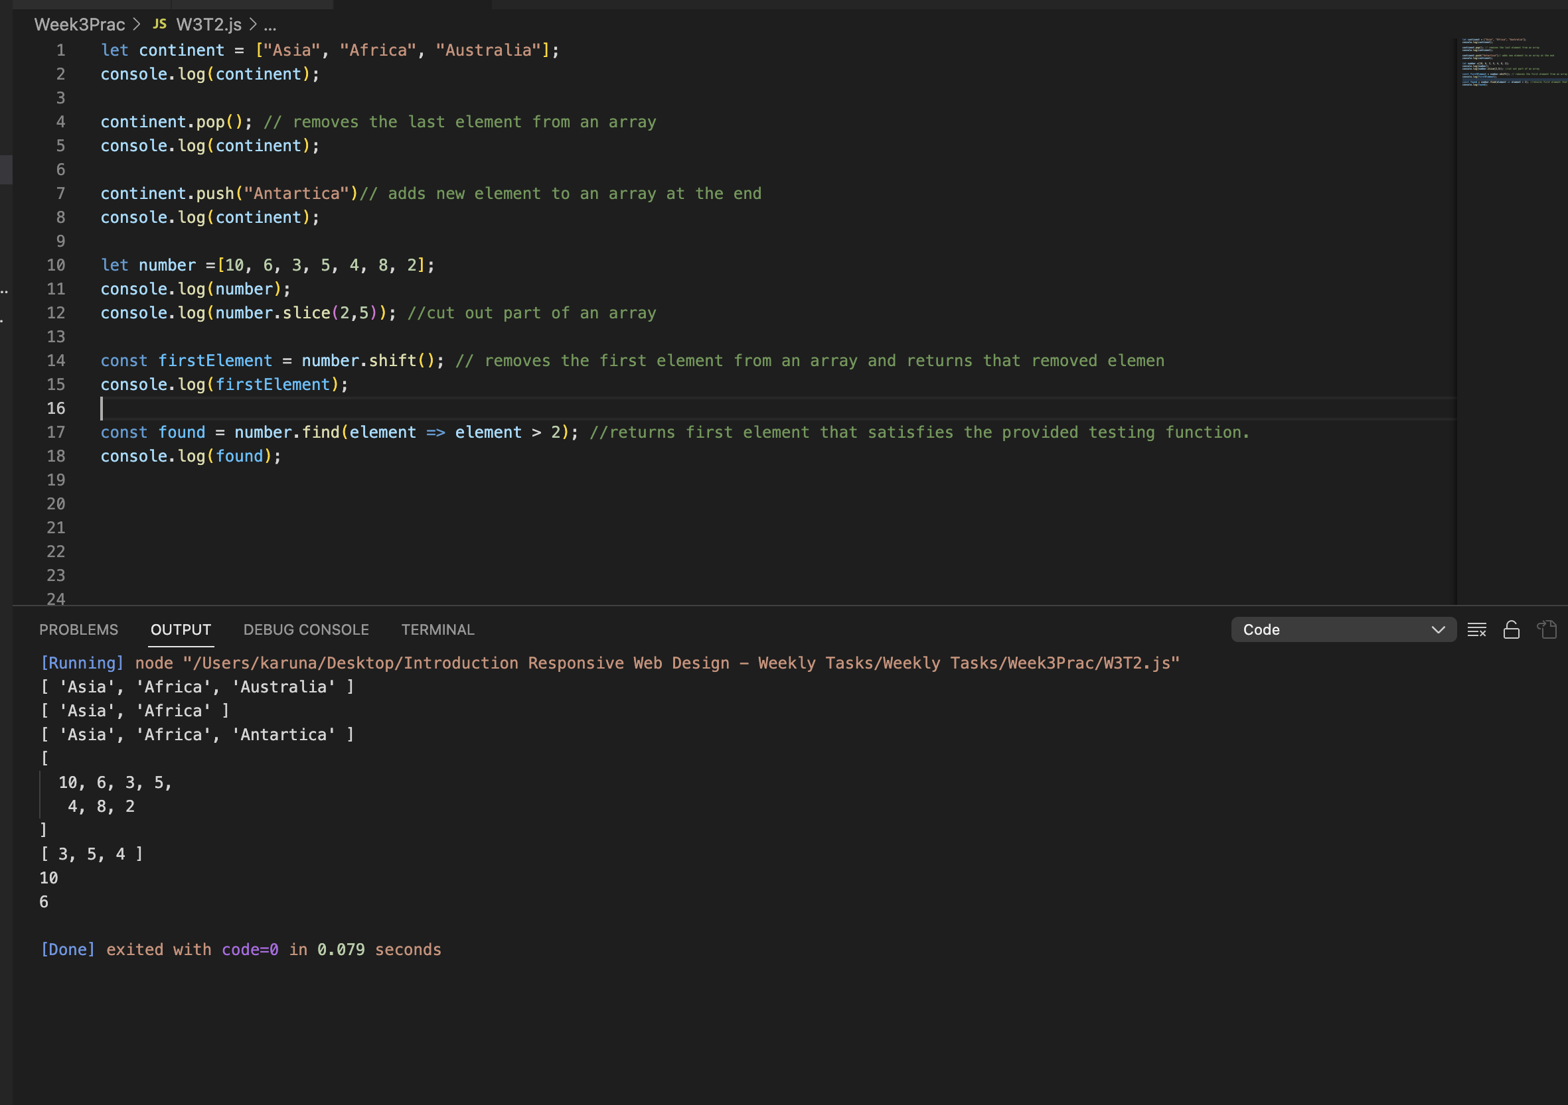

**Credit Task 3 – JavaScript Date API**

Reflection:

This task helped me to understand how to create a date object using new Date () constructor and once a date object is created, different methods allow to operate on it as shown in the picture below.

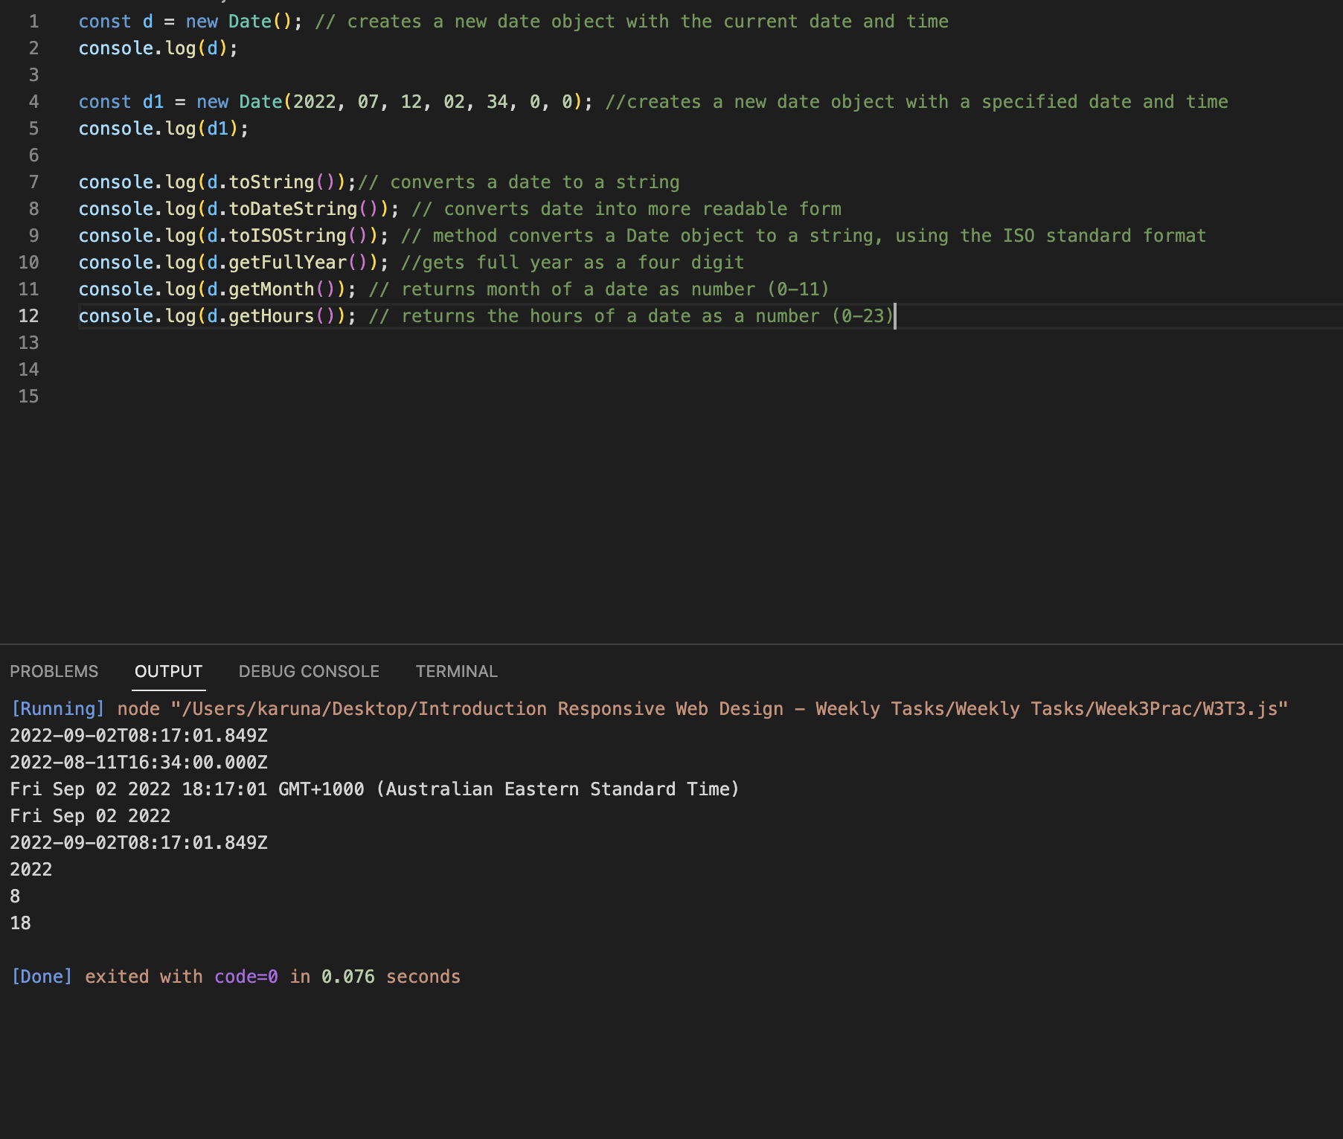

SIT120 - Introduction to Responsive Web Apps Week 4: Vue.js Framework

The easiest way to try out Vue is by building a Hello world app. The Installation — Vue.js (vuejs.org) for version 2 provides installing Vue and setup the project. **Hint**: use script tag: **<script src="https://cdn.jsdelivr.net/npm/vue@2.7.4/dist/vue.js"></script>**in your HTML head tag. Complete the tasks and write 1-2 sentences reflection for each task.

**List of Tasks:  
Pass Task 1 – Create basic Vue application**

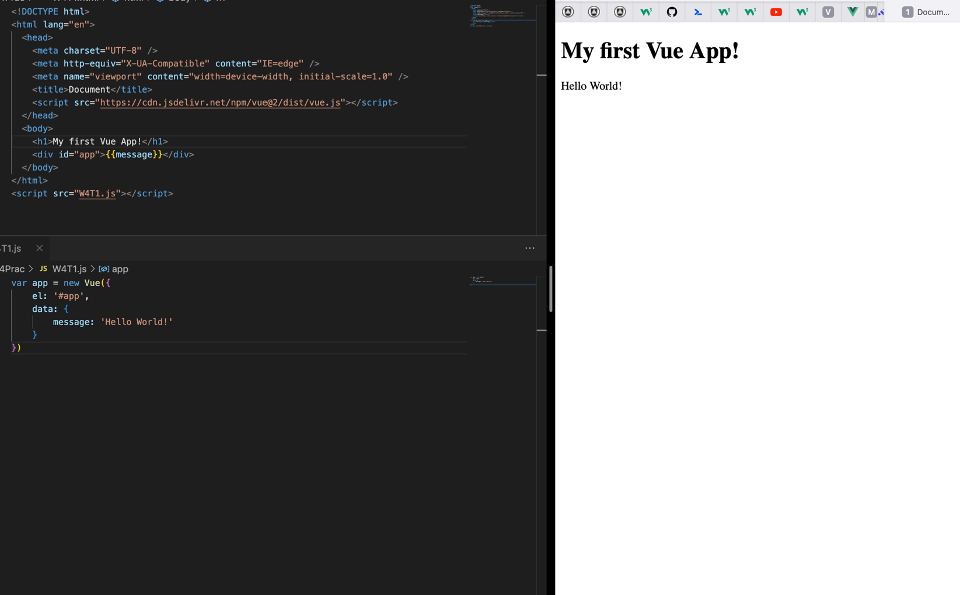

Reflection:

After completion of this task, I am able to understand and implement how to link Vue instance with html single element and control it.

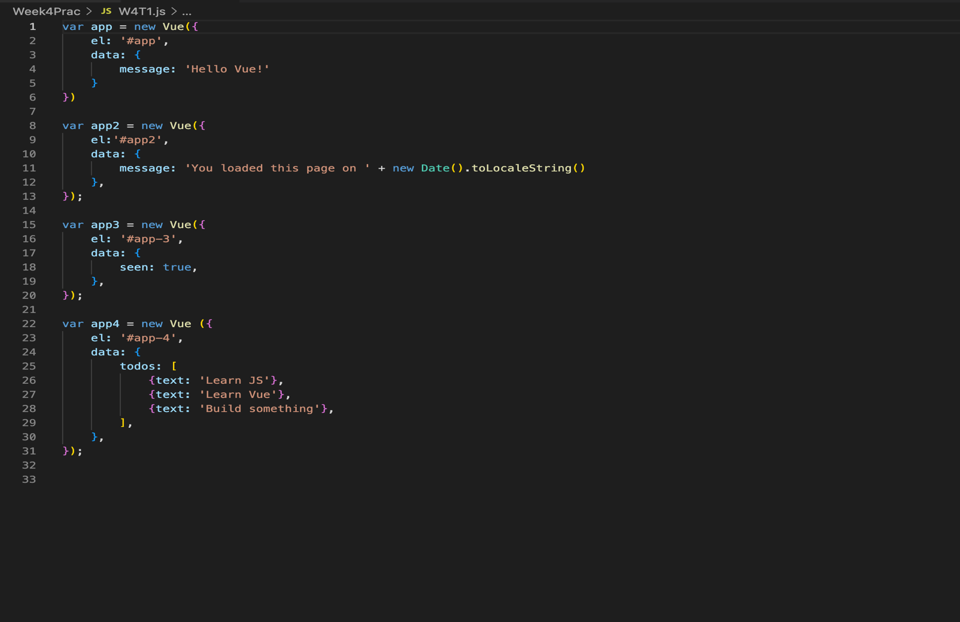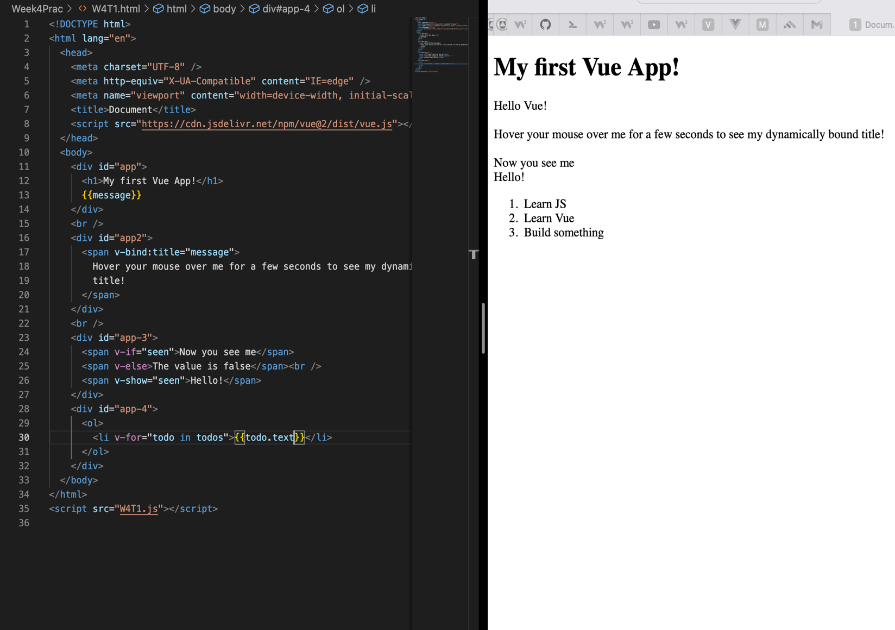**Credit Task 2 – Conditionals and Loops**

Reflection:

This task helped me to learn about conditional rendering and loops using Vue. I learned that directives are prefixed with v- to indicate that they are special attributes provided by Vue which apply special reactive behaviour to the rendered DOM.

**Distinction Task 3 – Implement Responsive Web design in Vue.**

You already learnt responsive web design and wrote reflections in week 2. Now try to implement that concept into Vue application using either flex box or grid(don’t use float). **Hint:** You may need to create more elements in order to show the responsive design. **Task to submit:** Implement responsive web design using either flex box or grid(don’t use float) in Vue (You may add into task 1).

Write 1-2 sentences reflection.

SIT120 - Introduction to Responsive Web Apps Week 5: Vue.js Framework

**Overview:**

This week, you will focus on gaining a better understanding of the Vue.js Framework and its different components and play with different examples.  
**NOTE: This week’s tasks are all about learning only, you do not need to push anything to GitHub. Just 1-2 sentences reflections needed for each task.**

**List of Tasks:  
Pass Task 1 – Components Basics**

**Instruction:** One of the important concepts in Vue are its components, that allows us to build large-scale applications on top of small and self-contained (often reusable) components. If we think about it, almost any type of application interface can be abstracted into a tree of components. For more detail use the link at

Reflection:

* Components are Vue instances which can be reused as many times as we want.
* Components data must be a function so that each instance can maintain an independent copy of the returned data object

**Credit Task 2 – Understanding Handling User Input  
Instruction: v-model** directive is used to create two-way data bindings on form elements like input or text area. Based on the type of input, the element is updated. Essentially, v- model is syntax sugar useful for updating data on events like user input. Visit Form Input Bindings to learn more.

Reflection:

* V-model directive is used to create two-way data bindings on form elements & based on the type of input, the element is updated.
* V-model will ignore the initial value, checked, or selected attributes found on any form elements.
* It will always treat the Vue instance data as the source of truth
* The initial value should be declared on the JavaScript side, inside the data option of a component

V-model internally uses different properties and emits different events for different input elements:

* Text and textarea elements use **value** property and **input** event
* Checkboxes and radio buttons use **checked** property and **change** event
* Select field use **value** as a prop and **change** as an event

**Distinction Task 3 – Learning Component Registration  
Instruction:** In a Vue application, component registration is necessary which means a component needs to be "registered" for Vue to know where to find its implementation when encountered in a template. There are two ways to register components: global and local. Learn how you can implement both ways.

Reflection:

* There’re two types of component registration: local and global
* When registering a component, it will always be given a name.
* The component’s name is the first argument of Vue.component

**Global registration:**

Syntax:

Vue.component (‘component-name’, {

// …. Options …..

})

These components are globally registered, and they can be used in the template of any root Vue instance created after registration.

Example: Vue.componet(‘component-a’, { ……. })

Vue.compoent(‘component-b’, { ……. })

New Vue ({ el: ‘#app’ })

This even applies to all subcomponents, meaning all two of these components will also be available inside each other.

**Local Registration:**

Global registration often isn’t quite ideal. In these cases, we can define our components as plain JavaScript objects:

Example: var ComponentA = { …. }

var ComponentB = { …. }

var ComponentC = { …. }

Then define the components to use in components option:

new Vue({

el: '#app',

components: {

'component-a': ComponentA,

'component-b': ComponentB

}

})

Locally registered components are not available in subcomponents.

The following example will show how to make componentA available in component,

var ComponentA = { /* ... */ }

var ComponentB = {

components: {

'component-a': ComponentA

},

// ...

}

**Distinction Task 4 – Learning Props, Events and Slots Instruction:**

* Props can be registered on a component and are used to pass data from a parent component to one of its children's components.
* A child component can emit custom events directly to parent component (e.g., in a v-on handler) using the built-in $emit method.
* With Vue slots, you can turn a part or all of your components into reusable templates that will render differently based on different use cases. That means you can add child element into your component tag e.g.,  
  <myComponent> <h1>Hello world</h1></myComponent> and this h1 hello world tag will replace the slot in myComponent template.

SIT120 - Introduction to Responsive Web Apps Week 6: Vue.js Framework (Handling User Inputs)

**Overview:**

In this week, you will gain a better understanding of Vue.js Framework. You will understand how to handle user inputs and form Input bindings. You will know how binding and modifiers work. Please write 1-2 sentences reflection for each task.  
**Note**: All the tasks can be written in one file/project, or you can create a new Vue application for each task. There’s no restriction.

**List of Tasks:  
Pass Task 1 – Using *v-model* directive for Handling User Input (Form Input Bindings) Instruction**:

Reflection:

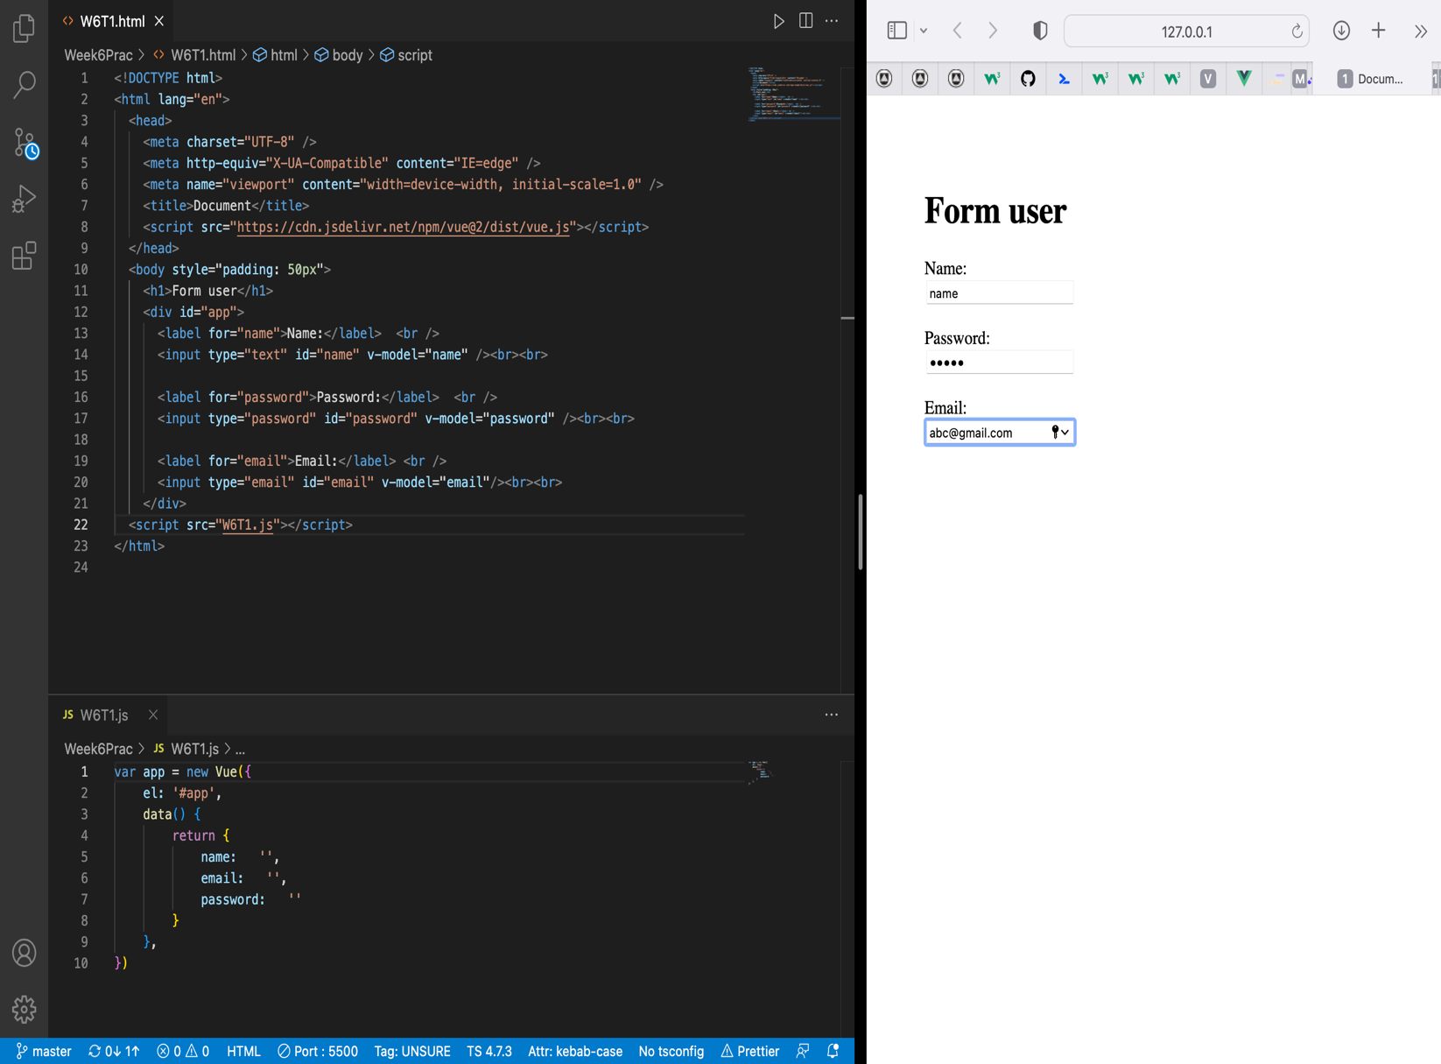V-model directive is implemented to perform two-way binding and handle user inputs.

**Pass Task 2 – Checkbox in your project  
Instruction:** Please visit this link to understand it more clearly. After that, Apply and implement a similar concept in your project. Please see the week 6 task 2 video tutorial for hints.  
**Task to submit:** Create a Vue application with checkbox. Below the input you must display the checked item on the page. Write 1-2 sentences reflection

Reflection:

With the help of this task, I was able to manipulate different checkbox options via vue instance implementing two way binding (v-model).

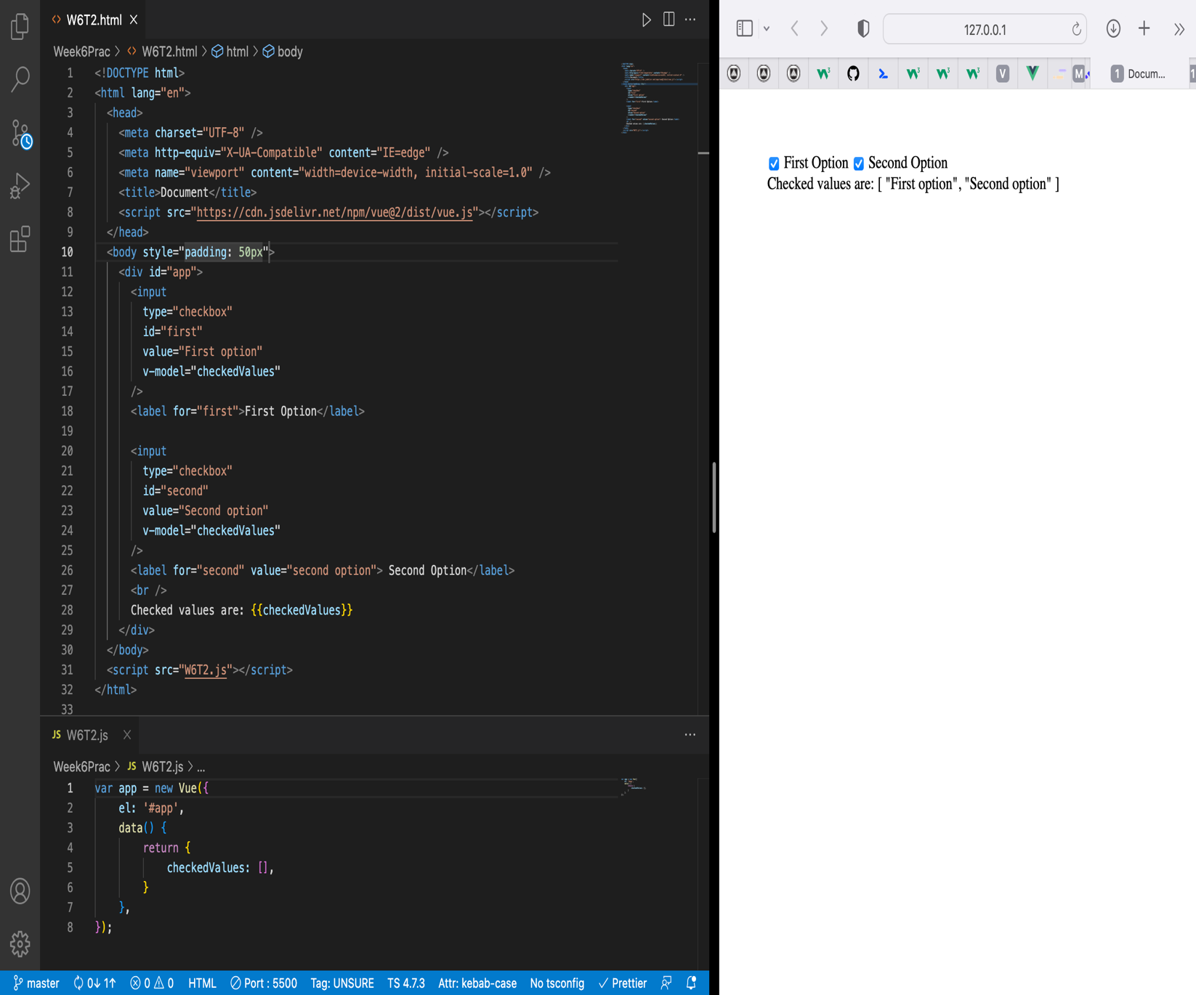

**Credit Task 3 – Dynamic options rendering using v-for**

Reflection:

This task helped me to implement v-for directive for dynamic options rendering

